Lab 3: Wi-Fi

University of Windsor
Department of Electrical and Computer Engineering
ELEC 8560 – Computer Networks
Semester: Fall 2023

Student Name: Amey Mahendra Thakur

Student number: 110107589

Answers:
- An SSID serves as a brief identification for an access point, typically consisting of one or two words. For instance, the SSID for Cisco-Li's access point includes "30 Munroe St" and "linsys_SES_24086," while LinksysG's SSID is labeled as "linksys12."

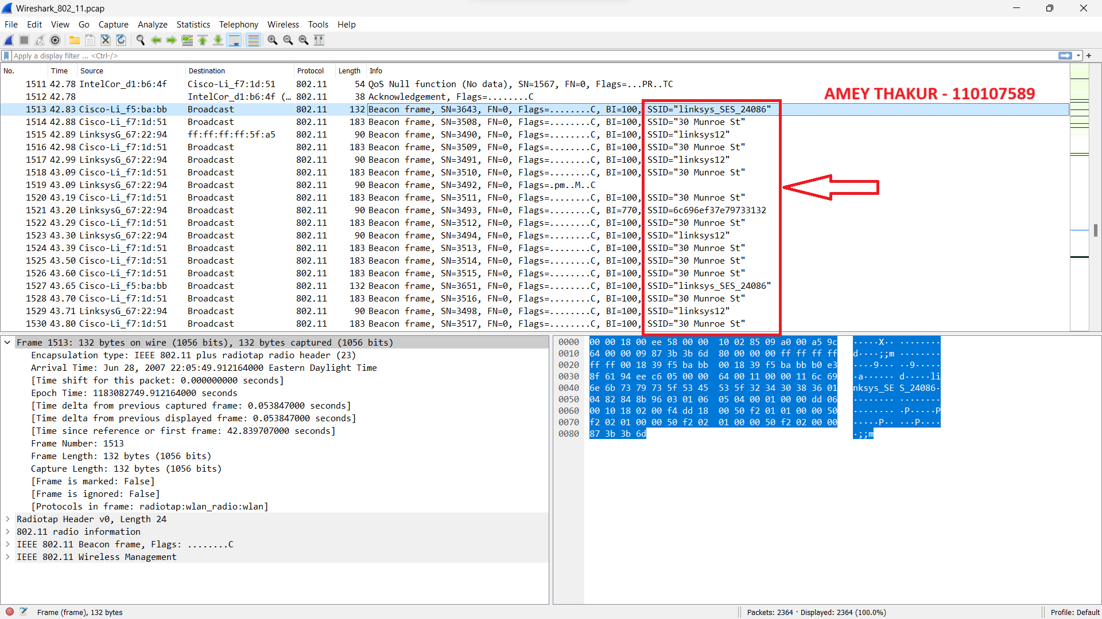

- The Beacon Interval for the 802.11 wireless LAN Management frame is set at 0.10200 seconds.

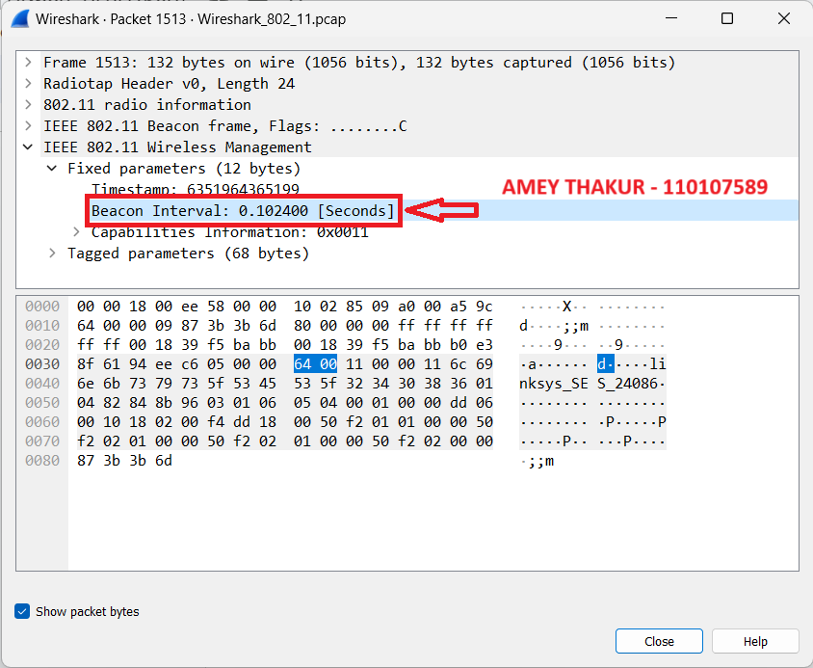

- The source MAC address found in the beacon frame transmitted from 30 Munroe St is 00:16:b6:f7:1d:51.

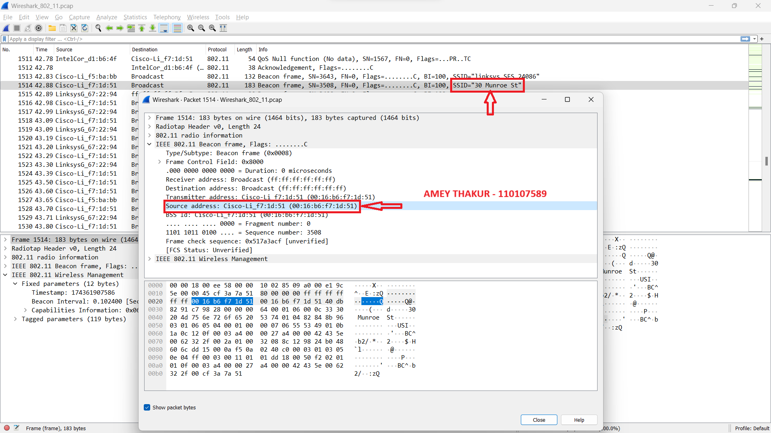
- The destination MAC address on the beacon frame from 30 Munroe St is represented in hexadecimal notation as "Broadcast" (ff:ff:ff:ff:ff:ff).

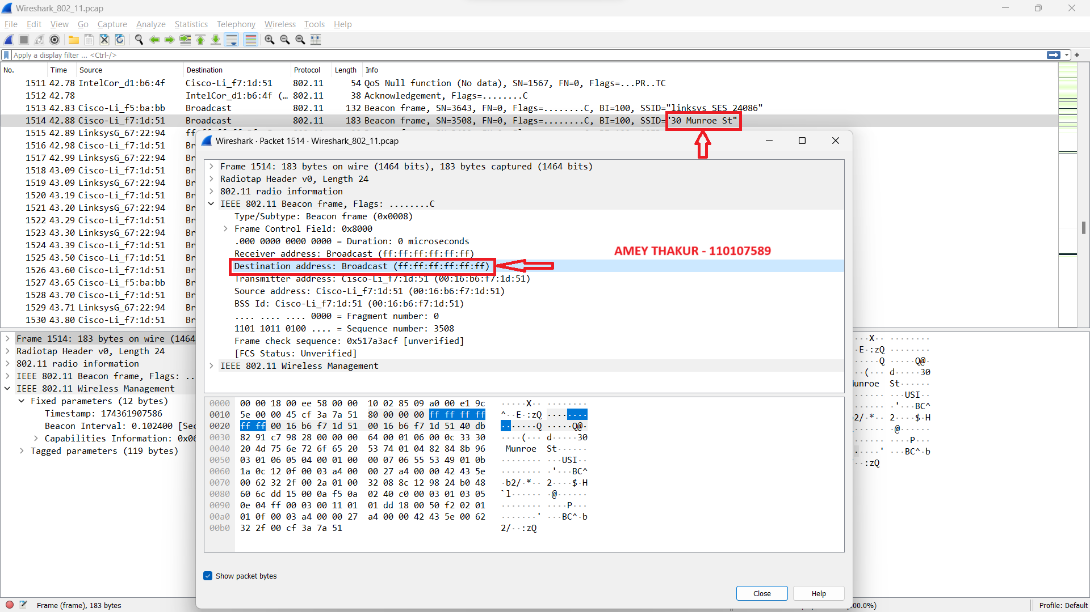

- The MAC BSS ID in hexadecimal notation found on the beacon frame for 30 Munroe St is identical to the source address, which is 00:16:b6:f7:1d:51.

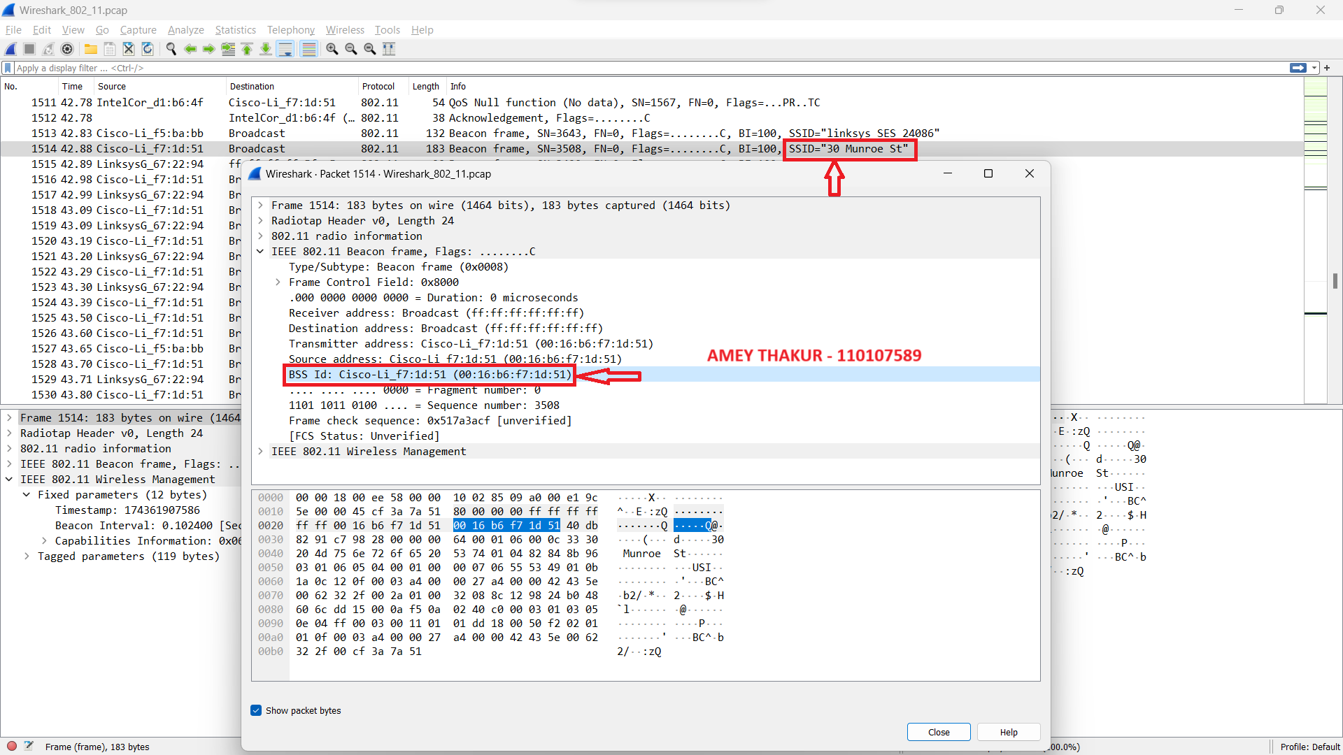

- The beacon frames transmitted by the 30 Munroe St access point indicate its capability to accommodate four primary data rates and eight supplementary "extended supported rates." These data rates are as follows:

Primary Supported Rates:
1 Mbps (B)
2 Mbps (B)
5.5 Mbps (B)
11 Mbps (B)

Extended Supported Rates:
6 Mbps (B)
9 Mbps
12 Mbps (B)
18 Mbps
24 Mbps (B)
36 Mbps
48 Mbps
54 Mbps

All of these rates are expressed in megabits per second (Mbps).

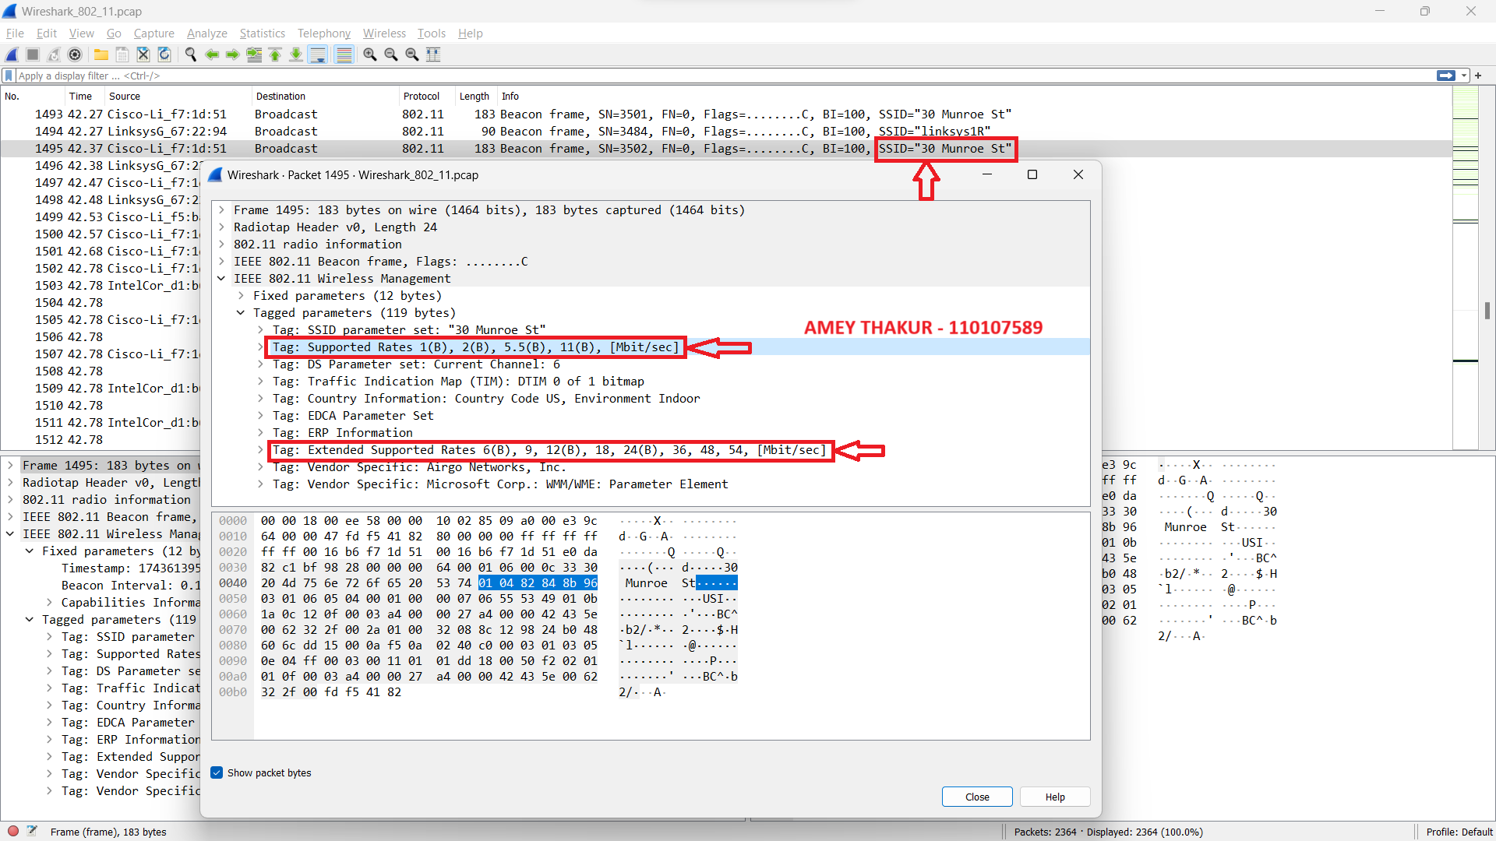

- The 802.11 frame containing the SYN TCP segment for the initial TCP session, which involves downloading "alice.txt," is located in Frame No. 474 at time t = 24.81. This frame includes three key MAC address fields:
- The Destination MAC address: 00:16:b6:f4:eb:a8, corresponds to the 1st hop router.
- The Source MAC address: 00:13:02:d1:b6:4f, represents the wireless host or computer.
- The BSS (Basic Service Set) ID: 00:16:b6:f7:1d:51, indicating the access point and serving as the first-hop router.

The IP addresses in this context are as follows:
- The Source IP address is 192.168.1.109, which corresponds to the IP address of the wireless host sending the SYN TCP segment.
- The Destination IP address is 128.119.245.12. This destination IP address typically corresponds to some network-attached device within the local network, possibly a device on the same subnet as the wireless host.

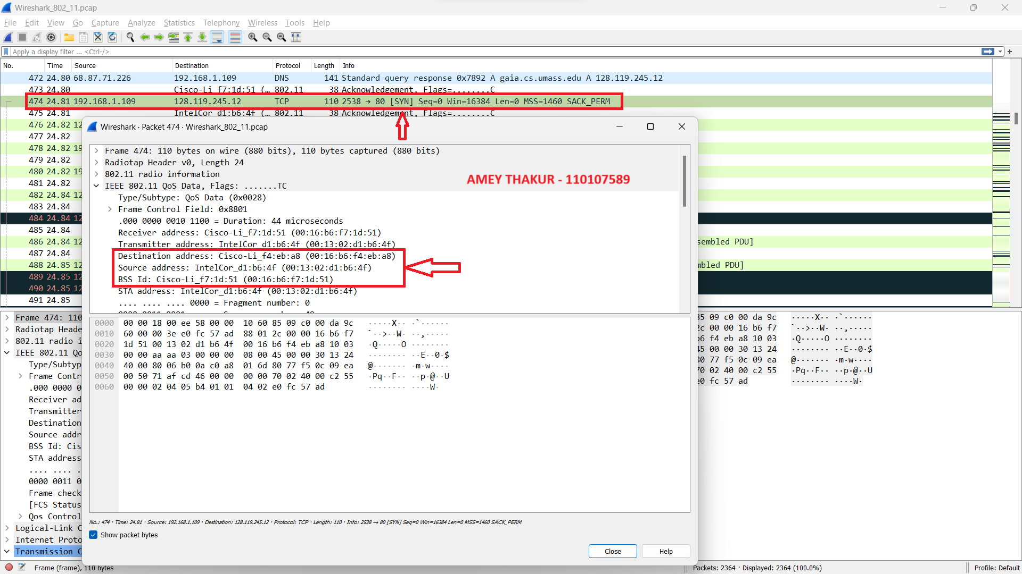

- In the 802.11 frame for the TCP session's SYNACK segment, there are three MAC addresses:

- Destination address (91:2a:b0:49:b6:4f): This MAC address corresponds to the host, as it's the intended recipient.
- BSS Id (00:16:b6:f7:1d:51): This MAC address is for the access point that the host is connected to.
- Source address (00:16:b6:f4:eb:a8): Typically, this MAC address corresponds to the first-hop router, the device sending data into the local network.

However, it's important to note that the MAC address in the frame does not directly align with the IP address of the device sending the TCP SYNACK segment. The TCP SYNACK was sent to the IP address 192.168.1.109, but the frame's destination MAC address is for the host (not 192.168.1.109), and the source MAC address is for the router (not the IP address 128.199.245.12). This discrepancy exists because MAC addresses are used for local network communication, while IP addresses are used for routing between networks. Address translation is typically handled by ARP in IPv4 networks.

